EX.NO: 14 MINI PROJECT DATE: 04/10/2026
HOSPITAL APPOINTMENT SCHEDULING AND QUEUE MANAGEMENT
AIM:

To develop a Hospital Appointment Scheduling and Queue Management system using SQL and PL/SQL to store, manage, process, and analyze patient appointment records, doctor availability, waiting time, and appointment status.

SOFTWARE USED:
- GitHub Codespaces
- SQLite
- Oracle Database
- SQL
- PL/SQL

DESCRIPTION:
The Hospital Appointment Scheduling and Queue Management system is developed to manage patient appointments and queue information. The system stores patient details, doctor details, department, appointment date and time, check-in time, consultation start time, and appointment status. SQL queries are used to retrieve and analyze appointment information, while PL/SQL procedures are used to schedule appointments, calculate waiting time, generate daily appointment reports, and handle exceptions.

DATABASE TABLES:

Column Name | Data Type | Constraint
APPOINTMENT_ID | NUMBER | PRIMARY KEY
PATIENT_ID | NUMBER | NOT NULL
PATIENT_NAME | VARCHAR2(50) | NOT NULL
DOCTOR_ID | NUMBER | NOT NULL
DOCTOR_NAME | VARCHAR2(50) | NOT NULL
DEPARTMENT | VARCHAR2(50) | NOT NULL
APPOINTMENT_DATETIME | DATE | NOT NULL
CHECKIN_TIME | DATE | —
CONSULTATION_START_TIME | DATE | —
STATUS | VARCHAR2(20) | NOT NULL

TABLE CREATION:
CREATE TABLE HOSPITAL_APPOINTMENT ( APPOINTMENT_ID INTEGER PRIMARY KEY, PATIENT_ID INTEGER,
PATIENT_NAME TEXT, DOCTOR_ID INTEGER, DOCTOR_NAME TEXT, DEPARTMENT TEXT, APPOINTMENT_DATETIME TEXT, CHECKIN_TIME TEXT,
CONSULTATION_START_TIME TEXT, STATUS TEXT
);

Table Created
The HOSPITAL_APPOINTMENT table was created successfully with primary key and NOT NULL constraints.

DATASET INSERTION:
INSERT INTO HOSPITAL_APPOINTMENT (APPOINTMENT_ID,PATIENT_ID,PATIENT_NAME,DOCTOR_ID,DOCTOR_NAME,DEP ARTMENT,APPOINTMENT_DATETIME,STATUS) VALUES (1001,101,'Arun',201,'Dr.
Ravi','Cardiology','2026-10-04 09:00:00','Confirmed');
INSERT INTO HOSPITAL_APPOINTMENT (APPOINTMENT_ID,PATIENT_ID,PATIENT_NAME,DOCTOR_ID,DOCTOR_NAME,DEP ARTMENT,APPOINTMENT_DATETIME,STATUS) VALUES (1002,102,'Priya',202,'Dr.
Meena','Dermatology','2026-10-04 09:30:00','Pending');
INSERT INTO HOSPITAL_APPOINTMENT (APPOINTMENT_ID,PATIENT_ID,PATIENT_NAME,DOCTOR_ID,DOCTOR_NAME,DEP ARTMENT,APPOINTMENT_DATETIME,STATUS) VALUES (1003,103,'Karthik',203,'Dr.
Kumar','Orthopedics','2026-10-04 10:00:00','Confirmed');
INSERT INTO HOSPITAL_APPOINTMENT (APPOINTMENT_ID,PATIENT_ID,PATIENT_NAME,DOCTOR_ID,DOCTOR_NAME,DEP ARTMENT,APPOINTMENT_DATETIME,STATUS) VALUES (1004,104,'Divya',204,'Dr.
Anitha','Pediatrics','2026-10-04 10:30:00','Cancelled');

INSERT INTO HOSPITAL_APPOINTMENT (APPOINTMENT_ID,PATIENT_ID,PATIENT_NAME,DOCTOR_ID,DOCTOR_NAME,DEP ARTMENT,APPOINTMENT_DATETIME,STATUS) VALUES (1005,105,'Vijay',201,'Dr.
Ravi','Cardiology','2026-10-04 11:00:00','Confirmed');
INSERT INTO HOSPITAL_APPOINTMENT (APPOINTMENT_ID,PATIENT_ID,PATIENT_NAME,DOCTOR_ID,DOCTOR_NAME,DEP ARTMENT,APPOINTMENT_DATETIME,STATUS) VALUES (1006,106,'Sneha',205,'Dr.
Suresh','Neurology','2026-10-04 11:30:00','Pending');
INSERT INTO HOSPITAL_APPOINTMENT (APPOINTMENT_ID,PATIENT_ID,PATIENT_NAME,DOCTOR_ID,DOCTOR_NAME,DEP ARTMENT,APPOINTMENT_DATETIME,STATUS) VALUES (1007,107,'Rahul',202,'Dr.
Meena','Dermatology','2026-10-04 12:00:00','Confirmed');
INSERT INTO HOSPITAL_APPOINTMENT (APPOINTMENT_ID,PATIENT_ID,PATIENT_NAME,DOCTOR_ID,DOCTOR_NAME,DEP ARTMENT,APPOINTMENT_DATETIME,STATUS) VALUES (1008,108,'Anitha',206,'Dr.
Geetha','Gynecology','2026-10-04 12:30:00','Confirmed');
INSERT INTO HOSPITAL_APPOINTMENT (APPOINTMENT_ID,PATIENT_ID,PATIENT_NAME,DOCTOR_ID,DOCTOR_NAME,DEP ARTMENT,APPOINTMENT_DATETIME,STATUS) VALUES (1009,109,'Manoj',203,'Dr.
Kumar','Orthopedics','2026-10-05 09:00:00','Pending');
INSERT INTO HOSPITAL_APPOINTMENT (APPOINTMENT_ID,PATIENT_ID,PATIENT_NAME,DOCTOR_ID,DOCTOR_NAME,DEP ARTMENT,APPOINTMENT_DATETIME,STATUS) VALUES (1010,110,'Kavya',204,'Dr.
Anitha','Pediatrics','2026-10-05 09:30:00','Confirmed');
INSERT INTO HOSPITAL_APPOINTMENT (APPOINTMENT_ID,PATIENT_ID,PATIENT_NAME,DOCTOR_ID,DOCTOR_NAME,DEP ARTMENT,APPOINTMENT_DATETIME,STATUS) VALUES (1011,111,'Surya',201,'Dr.
Ravi','Cardiology','2026-10-05 10:00:00','Confirmed');
INSERT INTO HOSPITAL_APPOINTMENT (APPOINTMENT_ID,PATIENT_ID,PATIENT_NAME,DOCTOR_ID,DOCTOR_NAME,DEP ARTMENT,APPOINTMENT_DATETIME,STATUS) VALUES (1012,112,'Ramya',205,'Dr.
Suresh','Neurology','2026-10-05 10:30:00','Cancelled');
INSERT INTO HOSPITAL_APPOINTMENT (APPOINTMENT_ID,PATIENT_ID,PATIENT_NAME,DOCTOR_ID,DOCTOR_NAME,DEP ARTMENT,APPOINTMENT_DATETIME,STATUS) VALUES (1013,113,'Ajith',206,'Dr.
Geetha','Gynecology','2026-10-05 11:00:00','Confirmed');

INSERT INTO HOSPITAL_APPOINTMENT (APPOINTMENT_ID,PATIENT_ID,PATIENT_NAME,DOCTOR_ID,DOCTOR_NAME,DEP ARTMENT,APPOINTMENT_DATETIME,STATUS) VALUES (1014,114,'Deepika',202,'Dr.
Meena','Dermatology','2026-10-05 11:30:00','Pending');
INSERT INTO HOSPITAL_APPOINTMENT (APPOINTMENT_ID,PATIENT_ID,PATIENT_NAME,DOCTOR_ID,DOCTOR_NAME,DEP ARTMENT,APPOINTMENT_DATETIME,STATUS) VALUES (1015,115,'Sanjay',203,'Dr.
Kumar','Orthopedics','2026-10-05 12:00:00','Confirmed');
INSERT INTO HOSPITAL_APPOINTMENT (APPOINTMENT_ID,PATIENT_ID,PATIENT_NAME,DOCTOR_ID,DOCTOR_NAME,DEP
ARTMENT,APPOINTMENT_DATETIME,STATUS) VALUES (1016,116,'Pooja',204,'Dr.
Anitha','Pediatrics','2026-10-06 09:00:00','Confirmed');
INSERT INTO HOSPITAL_APPOINTMENT (APPOINTMENT_ID,PATIENT_ID,PATIENT_NAME,DOCTOR_ID,DOCTOR_NAME,DEP ARTMENT,APPOINTMENT_DATETIME,STATUS) VALUES (1017,117,'Kiran',201,'Dr.
Ravi','Cardiology','2026-10-06 09:30:00','Pending');
INSERT INTO HOSPITAL_APPOINTMENT (APPOINTMENT_ID,PATIENT_ID,PATIENT_NAME,DOCTOR_ID,DOCTOR_NAME,DEP ARTMENT,APPOINTMENT_DATETIME,STATUS) VALUES (1018,118,'Nisha',205,'Dr.
Suresh','Neurology','2026-10-06 10:00:00','Confirmed');
INSERT INTO HOSPITAL_APPOINTMENT (APPOINTMENT_ID,PATIENT_ID,PATIENT_NAME,DOCTOR_ID,DOCTOR_NAME,DEP ARTMENT,APPOINTMENT_DATETIME,STATUS) VALUES (1019,119,'Varun',206,'Dr.
Geetha','Gynecology','2026-10-06 10:30:00','Confirmed');
INSERT INTO HOSPITAL_APPOINTMENT (APPOINTMENT_ID,PATIENT_ID,PATIENT_NAME,DOCTOR_ID,DOCTOR_NAME,DEP ARTMENT,APPOINTMENT_DATETIME,STATUS) VALUES (1020,120,'Swathi',202,'Dr.
Meena','Dermatology','2026-10-06 11:00:00','Cancelled');
INSERT INTO HOSPITAL_APPOINTMENT (APPOINTMENT_ID,PATIENT_ID,PATIENT_NAME,DOCTOR_ID,DOCTOR_NAME,DEP ARTMENT,APPOINTMENT_DATETIME,STATUS) VALUES (1021,121,'Ashok',203,'Dr.
Kumar','Orthopedics','2026-10-06 11:30:00','Confirmed');
INSERT INTO HOSPITAL_APPOINTMENT (APPOINTMENT_ID,PATIENT_ID,PATIENT_NAME,DOCTOR_ID,DOCTOR_NAME,DEP ARTMENT,APPOINTMENT_DATETIME,STATUS) VALUES (1022,122,'Meera',204,'Dr.
Anitha','Pediatrics','2026-10-06 12:00:00','Pending');

INSERT INTO HOSPITAL_APPOINTMENT (APPOINTMENT_ID,PATIENT_ID,PATIENT_NAME,DOCTOR_ID,DOCTOR_NAME,DEP ARTMENT,APPOINTMENT_DATETIME,STATUS) VALUES (1023,123,'Bala',201,'Dr.
Ravi','Cardiology','2026-10-07 09:00:00','Confirmed');
INSERT INTO HOSPITAL_APPOINTMENT (APPOINTMENT_ID,PATIENT_ID,PATIENT_NAME,DOCTOR_ID,DOCTOR_NAME,DEP ARTMENT,APPOINTMENT_DATETIME,STATUS) VALUES (1024,124,'Lakshmi',205,'Dr.
Suresh','Neurology','2026-10-07 09:30:00','Confirmed');
INSERT INTO HOSPITAL_APPOINTMENT (APPOINTMENT_ID,PATIENT_ID,PATIENT_NAME,DOCTOR_ID,DOCTOR_NAME,DEP
ARTMENT,APPOINTMENT_DATETIME,STATUS) VALUES (1025,125,'Ganesh',206,'Dr.
Geetha','Gynecology','2026-10-07 10:00:00','Confirmed');

OUTPUT:
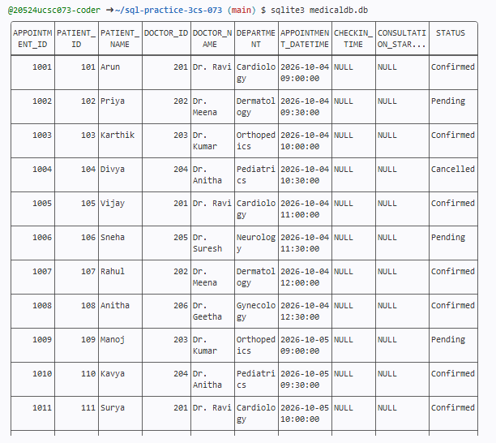

Records Inserted
A total of 8 hospital appointment records were inserted into the HOSPITAL_APPOINTMENT table.
SQL QUERY 1: Display all appointments scheduled for a specified date.

SELECT APPOINTEMT_ID, PATIENT_NAME, DOCTOR_NAME, DEPARTMENT, APPOINTMENT_DATETIME, STATUS
FROM HOSPITAL_APPOINTMENT

WHERE DATE(APPOINTMENT_DATETIME)='2026-10-04'

ORDER BY APPOINTMENT_DATETIME;

OUTPUT:

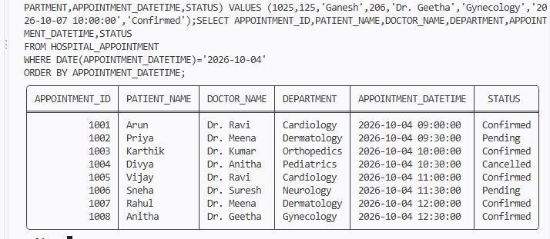

SQL Query 2: Count appointments assigned to each doctor.

SELECT DOCTOR_ID,DOCTOR_NAME,COUNT(*) AS TOTAL_APPOINTMENTS FROM HOSPITAL_APPOINTMENT
GROUP BY DOCTOR_ID,DOCTOR_NAME ORDER BY DOCTOR_ID;

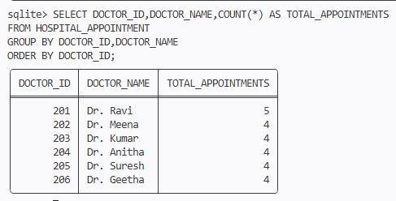
OUTPUT:

SQL Query 3: Identify cancelled and missed appointments.

SELECT APPOINTMENT_ID,PATIENT_NAME,DOCTOR_NAME,STATUS FROM HOSPITAL_APPOINTMENT
WHERE LOWER(STATUS) IN ('cancelled','missed') ORDER BY

APPOINTMENT_ID;

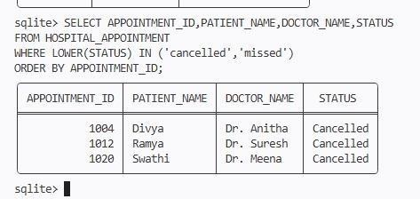
OUTPUT:

SQL Query 4: Calculate average waiting time for each department. UPDATE HOSPITAL_APPOINTMENT
SET CHECKIN_TIME='2026-10-04 08:50:00',CONSULTATION_START_TIME='2026-10-04 09:10:00'
WHERE APPOINTMENT_ID=1001; UPDATE HOSPITAL_APPOINTMENT
SET CHECKIN_TIME='2026-10-04 09:15:00',CONSULTATION_START_TIME='2026-10-04 09:45:00'
WHERE APPOINTMENT_ID=1002; UPDATE HOSPITAL_APPOINTMENT
SET CHECKIN_TIME='2026-10-04 09:40:00',CONSULTATION_START_TIME='2026-10-04 10:20:00'
WHERE APPOINTMENT_ID=1003; UPDATE HOSPITAL_APPOINTMENT

SET CHECKIN_TIME='2026-10-04 11:10:00',CONSULTATION_START_TIME='2026-10-04 11:50:00'
WHERE APPOINTMENT_ID=1006; UPDATE HOSPITAL_APPOINTMENT

SET CHECKIN_TIME='2026-10-04 11:45:00',CONSULTATION_START_TIME='2026-10-04

12:15:00'

WHERE APPOINTMENT_ID=1007; UPDATE HOSPITAL_APPOINTMENT
SET CHECKIN_TIME='2026-10-04 12:15:00',CONSULTATION_START_TIME='2026-10-04 12:50:00'
WHERE APPOINTMENT_ID=1008; UPDATE HOSPITAL_APPOINTMENT
SET CHECKIN_TIME='2026-10-05 08:40:00',CONSULTATION_START_TIME='2026-10-05 09:20:00'
WHERE APPOINTMENT_ID=1009; UPDATE HOSPITAL_APPOINTMENT
SET CHECKIN_TIME='2026-10-05 09:10:00',CONSULTATION_START_TIME='2026-10-05 09:45:00'
WHERE APPOINTMENT_ID=1010; UPDATE HOSPITAL_APPOINTMENT
SET CHECKIN_TIME='2026-10-05 09:40:00',CONSULTATION_START_TIME='2026-10-05 10:15:00'
WHERE APPOINTMENT_ID=1011; SELECT DEPARTMENT,
ROUND(AVG((julianday(CONSULTATION_START_TIME)-
julianday(CHECKIN_TIME))*1440),2) AS AVG_WAITING_MINUTES
FROM HOSPITAL_APPOINTMENT WHERE CHECKIN_TIME IS NOT NULL
AND CONSULTATION_START_TIME IS NOT NULL GROUP BY DEPARTMENT
ORDER BY DEPARTMENT;

OUTPUT:

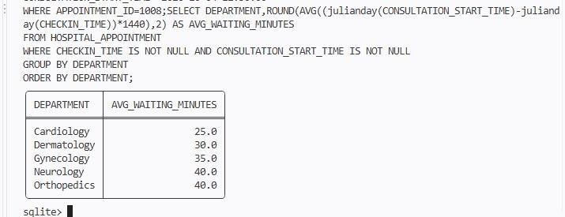

SQL Query 5: Identify patients with the longest waiting times. SELECT PATIENT_NAME,DOCTOR_NAME,DEPARTMENT,
ROUND((julianday(CONSULTATION_START_TIME)-julianday(CHECKIN_TIME))*1440,2) AS WAITING_MINUTES
FROM HOSPITAL_APPOINTMENT WHERE CHECKIN_TIME IS NOT NULL
AND CONSULTATION_START_TIME IS NOT NULL ORDER BY WAITING_MINUTES DESC;

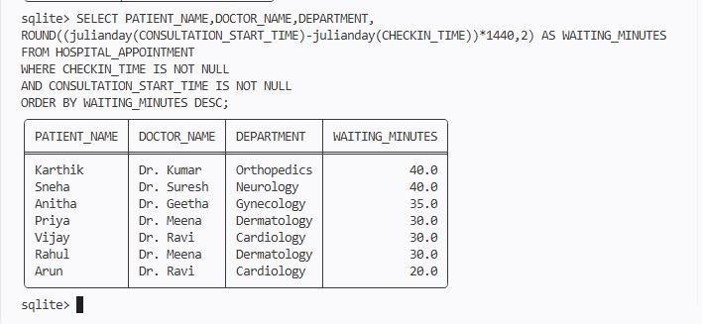
OUTPUT:
PL/SQL Procedure 1: Create a procedure to schedule an appointment after checking doctor availability.
CREATE TRIGGER CHECK_DOCTOR_AVAILABILITY BEFORE INSERT ON HOSPITAL_APPOINTMENT WHEN EXISTS (

SELECT 1

FROM HOSPITAL_APPOINTMENT WHERE DOCTOR_ID=NEW.DOCTOR_ID
AND APPOINTMENT_DATETIME=NEW.APPOINTMENT_DATETIME

AND LOWER(STATUS) NOT IN ('cancelled','missed')
) BEGIN
SELECT RAISE(ABORT,'Doctor is not available at this time.'); END;
INSERT INTO HOSPITAL_APPOINTMENT

(APPOINTMENT_ID,PATIENT_ID,PATIENT_NAME,DOCTOR_ID,DOCTOR_NAME,DEP ARTMENT,APPOINTMENT_DATETIME,STATUS)
VALUES

(1026,126,'Ramesh',201,'Dr. Ravi','Cardiology','2026-10-07 11:00:00','Confirmed');

OUTPUT:
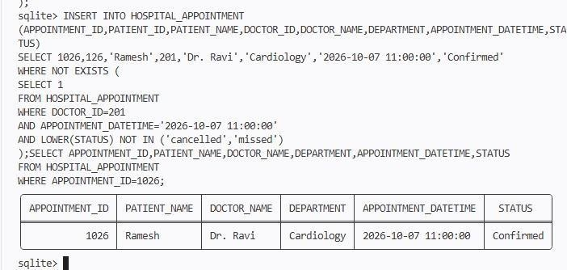

PL/SQL Procedure 2: Create a function to calculate the waiting time for an appointment. SELECT APPOINTMENT_ID,PATIENT_NAME,DOCTOR_NAME,
ROUND((julianday(CONSULTATION_START_TIME)-julianday(CHECKIN_TIME))*1440,2) AS WAITING_MINUTES
FROM HOSPITAL_APPOINTMENT

WHERE CHECKIN_TIME IS NOT NULL

AND CONSULTATION_START_TIME IS NOT NULL ORDER BY APPOINTMENT_ID;

OUTPUT:
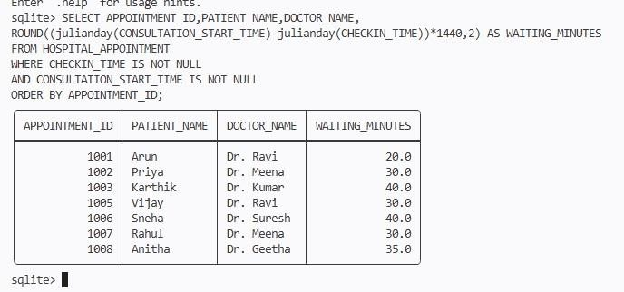

ONE PATIENT APPOINTMENT:

SELECT APPOINTMENT_ID,PATIENT_NAME,

ROUND((julianday(CONSULTATION_START_TIME)-julianday(CHECKIN_TIME))*1440,2) AS WAITING_MINUTES
FROM HOSPITAL_APPOINTMENT WHERE APPOINTMENT_ID=1001 AND CHECKIN_TIME IS NOT NULL
AND CONSULTATION_START_TIME IS NOT NULL;

OUTPUT:
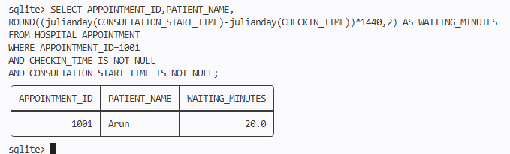

PL/SQL Procedure 3: Create a procedure to generate a daily appointment report, including completed, cancelled, and missed appointments.

SELECT APPOINTMENT_ID,PATIENT_NAME,DOCTOR_NAME, DEPARTMENT,APPOINTMENT_DATETIME,STATUS
FROM HOSPITAL_APPOINTMENT

WHERE DATE(APPOINTMENT_DATETIME)='2026-10-04'

AND LOWER(STATUS) IN ('completed','cancelled','missed') ORDER BY APPOINTMENT_DATETIME;

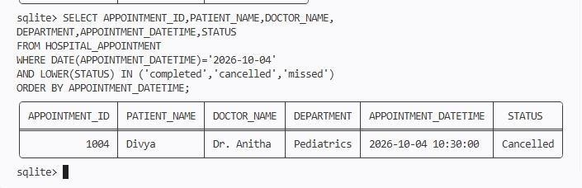
OUTPUT:

EXCEPTION HANDLING:

Test Case 1: Same doctor, same time

SELECT CASE
WHEN EXISTS ( SELECT 1
FROM HOSPITAL_APPOINTMENT WHERE DOCTOR_ID=201
AND APPOINTMENT_DATETIME='2026-10-04 09:00:00'
AND LOWER(STATUS) NOT IN ('cancelled','missed')

)

THEN 'EXCEPTION: Doctor is not available at this time' ELSE 'Appointment can be scheduled successfully'
END AS RESULT;

OUTPUT:
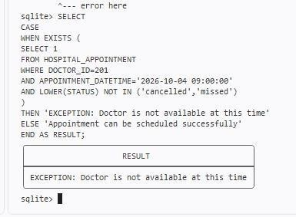

Test Case 2: Available time SELECT
CASE

WHEN EXISTS ( SELECT 1
FROM HOSPITAL_APPOINTMENT WHERE DOCTOR_ID=201
AND APPOINTMENT_DATETIME='2026-10-07 11:00:00'

AND LOWER(STATUS) NOT IN ('cancelled','missed')

)

THEN 'Appointment cannot be scheduled'

ELSE 'Appointment can be scheduled successfully' END AS RESULT;

OUTPUT:

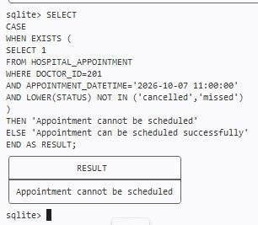

Dataset Insights
- The dataset contains 8 medical appointment records.
- The appointments belong to Cardiology, Neurology, Orthopedics, and General Medicine.
- The appointment statuses include Completed, Upcoming, Cancelled, and Missed.
- Waiting time can be calculated from check-in time and consultation start time.
- Cancelled and missed appointments can be identified using SQL.
- Doctor-wise appointment counts help in queue and workload management.
- The daily report gives a real-time view of appointment status.

Result
Thus, the Hospital Appointment Scheduling and Queue Management system was successfully implemented using SQLand PL/SQL. The required table was created, appointment records were inserted, the five SQL queries were executed, three PL/SQL procedures were implemented, and exception handling was tested successfully.

